Introduction
Section 7.2.3 of Saddington Parish Neighbourhood Plan describes Local Green Spaces that are considered to be important to the character of Saddington. Of the approximately 175 inventoried parcels of open land in the parish (refer to Neighbourhood Plan appendix 5) some 26 were identified as having notable environmental (natural, historical and/or cultural) features. These sites were scored, using the nine criteria for Local Green Space designation noted in the National Planning Policy Framework 2012 (see Neighbourhood Plan figure 5 for the criteria and scoring system adopted for this Plan).
Five sites score 75% (24/32) or more of the maximum possible and meet the essential requirements for designation as Local Green Space as outlined in the National Planning Policy Framework (NPPF paragraph 77). Two are already protected by national designations (as SSSI and Listed Building, respectively).
The remaining three are designated in the Neighbourhood Plan as Local Green Spaces to ensure that these most important places in Saddington’s natural and human environment are also statutorily protected, other than in exceptional circumstances. The three spaces are shown in the figure below:
LGS 1) Bullbeds field (Inventory reference 037)
LGS 2) Smeeton Road Allotment gardens (Inventory reference 171)
LGS 3) Saddington Cemetery, Smeeton Road (Inventory reference 172)
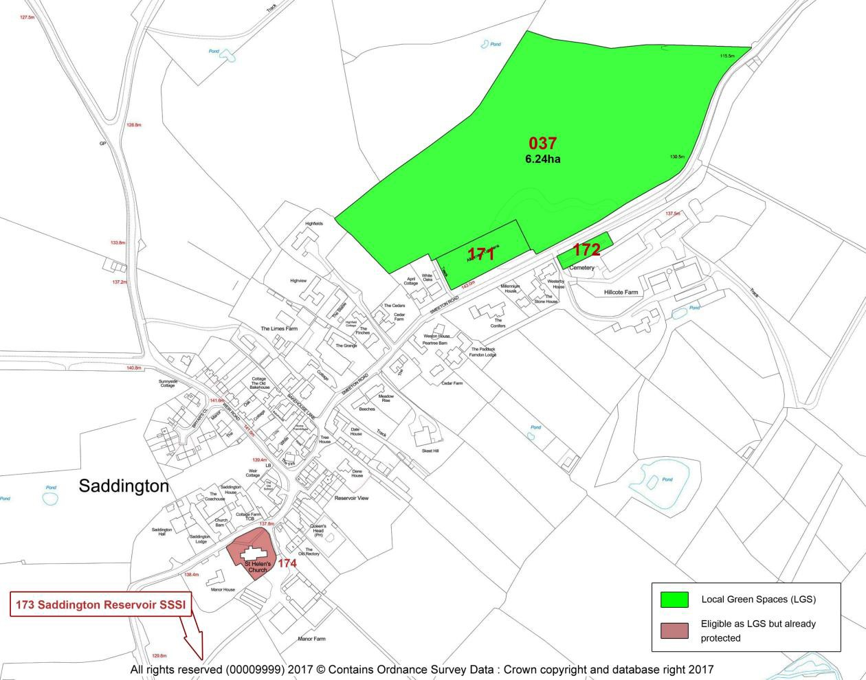
Saddington Local Green Spaces

Local Green Space 1) Bullbeds (Inventory reference 037)
Ref. | EVIDENCE | NPPF (2012) ELIGIBILITY CRITERIA
 |  | Access /4 | Proximity /4 | Bounded /4 | Special /4 | Rec/Ed /4 | Beauty/ Views /2 | Tranquillity /2 | History /4 | Wildlife /4 | TOTAL
037 | Bullbeds field  Permanent grass field, grazed, at summit and on eastern slopes of Saddington hill.  Access via footpath Y3a and local custom, well-used (locals and visitors, dog-walkers); also traditional sledging field.  Includes parts of old gravel pits (earthworks, recorded as a monument in L&R HER), plus good ridge and furrow.  Extensive panoramic views.  Hedged boundaries. Semi-improved grassland flora, 2 BAP species birds (plus some 20 further species records), mammals, invertebrates. The adjacent canal (SSSI) augments the biodiversity of this parcel along its northern boundary | 3 | 3 | 3 | 3 | 3 | 2 | 2 | 3 | 3 | 25
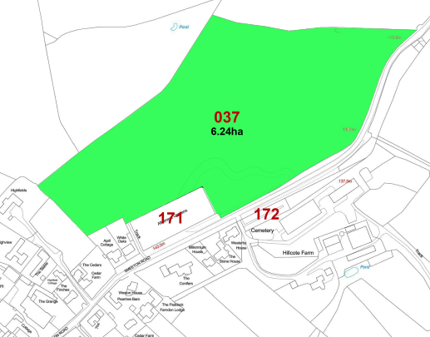  Bullbeds field - location |  | 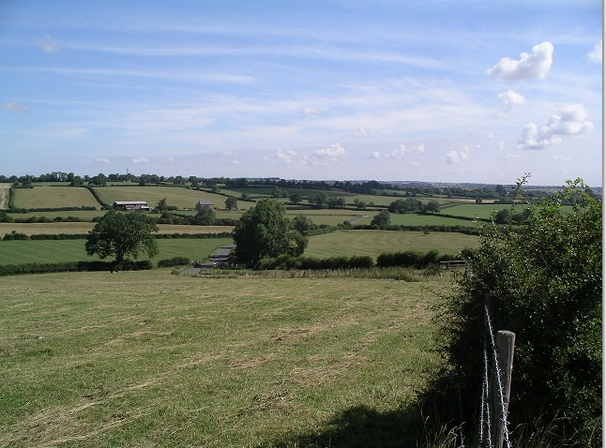  Bullbeds field
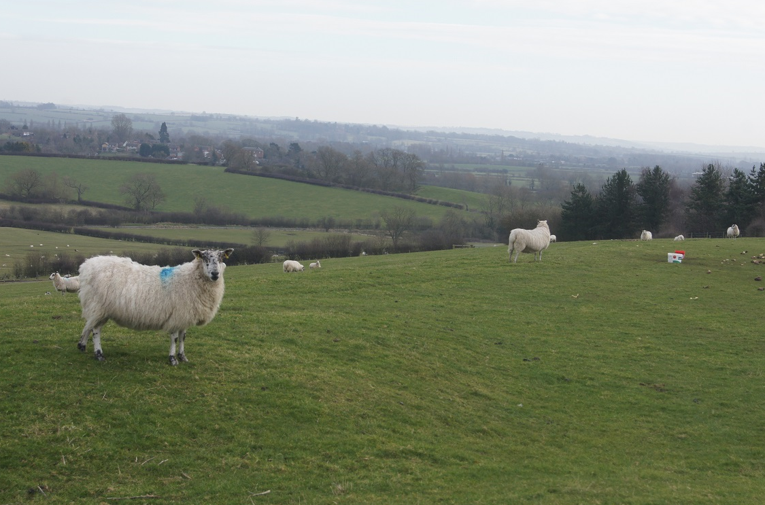  Bullbeds field |  | 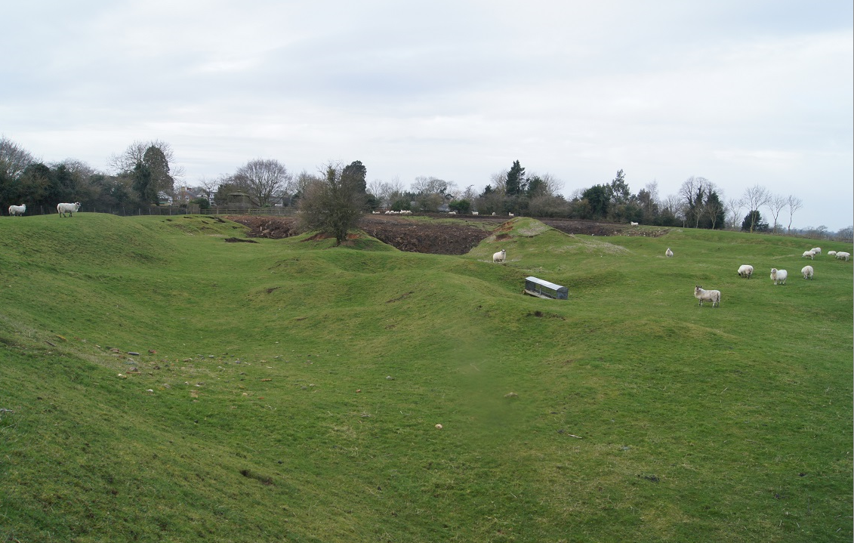  Bullbeds field

Local Green Space 2) Allotment gardens (171)
Ref. | EVIDENCE | NPPF (2012) ELIGIBILITY CRITERIA
 |  | Access /4 | Proximity /4 | Bounded /4 | Special /4 | Rec/Ed /4 | Beauty/ Views /2 | Tranquillity /2 | History /4 | Wildlife /4 | TOTAL
171 | Smeeton Road Allotment gardens  Well-used community facility. OSSR site managed by Harborough District Council.  Rectangular depression, the site of gravel pit(s) worked since before 1830, re-worked by 1904 to create the present land parcel.  Central area holds c.25 allotments (in use) plus an area of rough grass and scrub. Cultivated land, sheds and greenhouses, fruit trees, etc. The banks are steep, with trees and scrub.  Part of L&R HER site MLE21996 for old gravel diggings.  High local biodiversity significance for garden birds (3 BAP species, plus others), mammals (including bat foraging area) and invertebrates. | 3 | 4 | 4 | 3 | 3 | 2 | 2 | 2 | 3 | 26
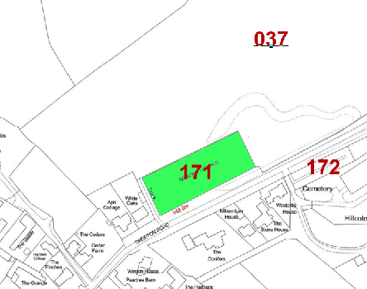  Smeeton Road Allotment Gardens - location |  | 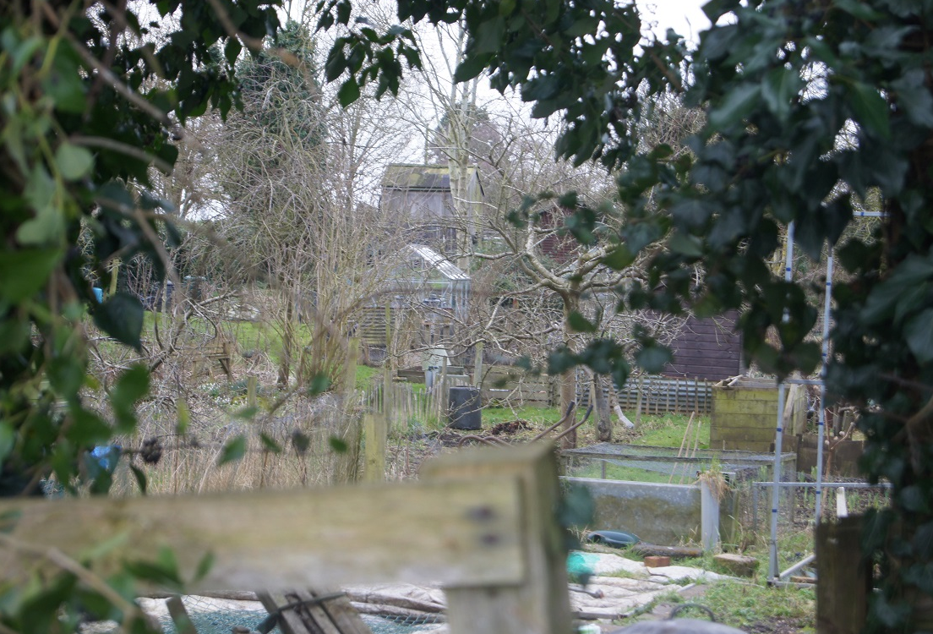  Smeeton Road Allotment Gardens
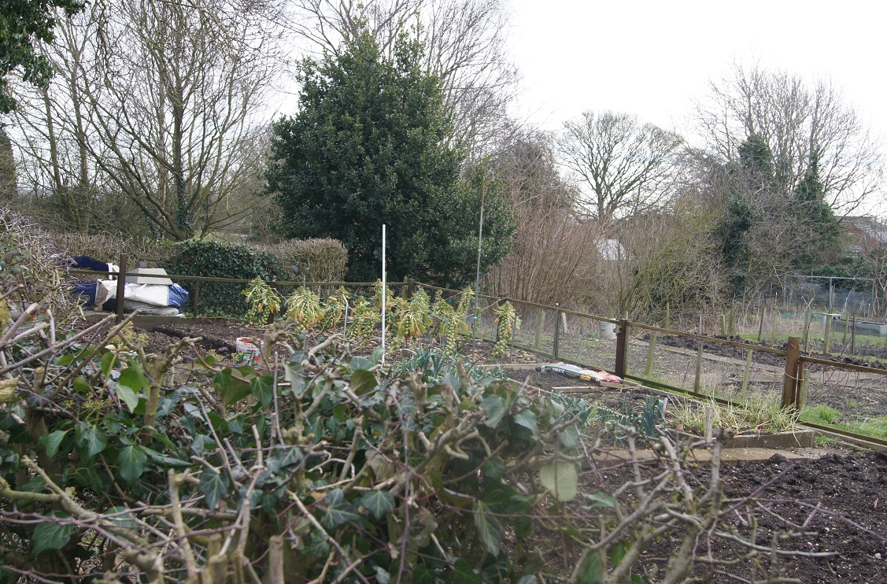  Smeeton Road Allotment Gardens |  | 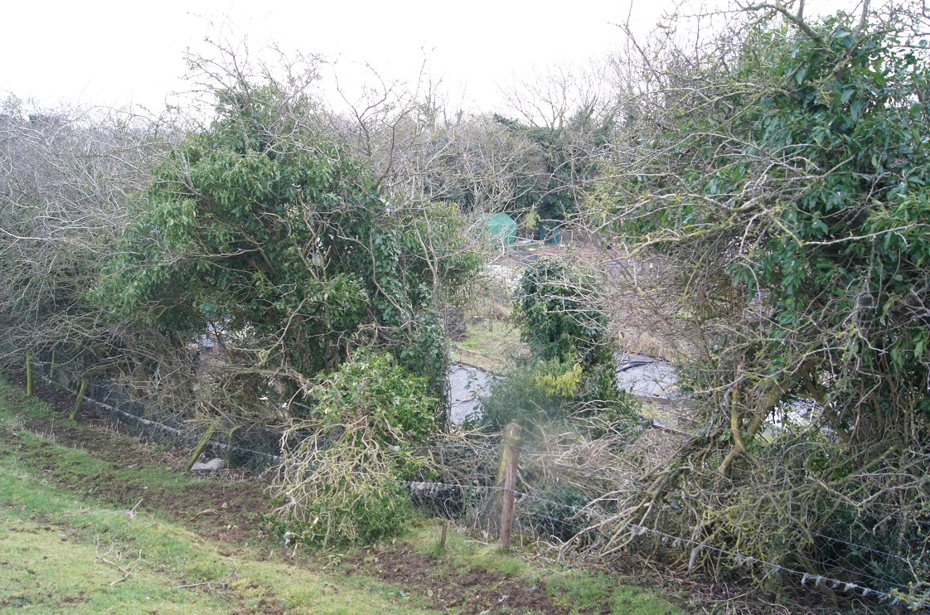  Smeeton Road Allotment Gardens
OSSR = Open Space, Sport and Recreation Site

Local Green Space 3) Saddington Cemetery (172)
Ref. | EVIDENCE | NPPF (2012) ELIGIBILITY CRITERIA
 |  | Access /4 | Proximity /4 | Bounded /4 | Special /4 | Rec/Ed /4 | Beauty/ Views /2 | Tranquillity /2 | History /4 | Wildlife /4 | TOTAL
172 | Smeeton Road Cemetery  The Smeeton Road cemetery is an open cemetery that is managed by Harborough District Council, with hedged boundaries to north and south.  Burial plots, lawns, ornamental planting and trees, serves as a small public park with seating. Extensive views southward.  Located at the north-eastern end of Saddington settlement on the Smeeton Road. | 4 | 3 | 4 | 3 | 3 | 2 | 2 | 2 | 2 | 25
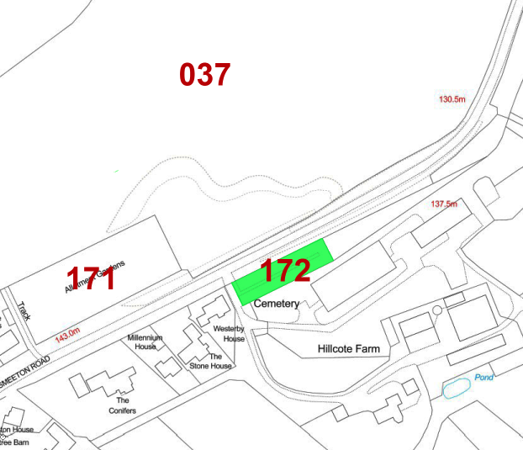  Smeeton Road Cemetery - location |  | 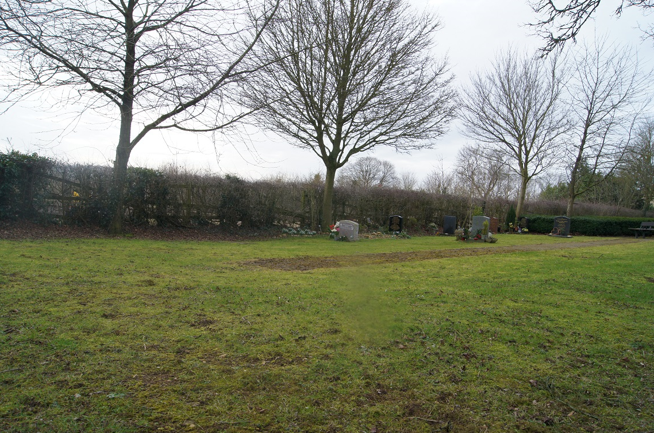  Smeeton Road Cemetery
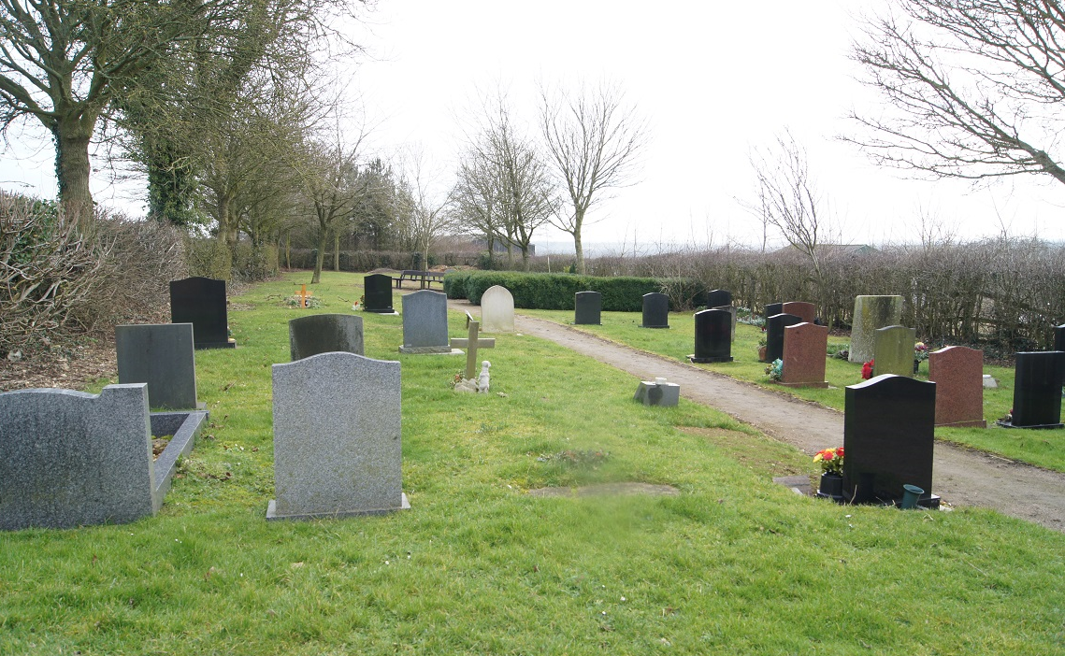  Smeeton Road Cemetery |  | 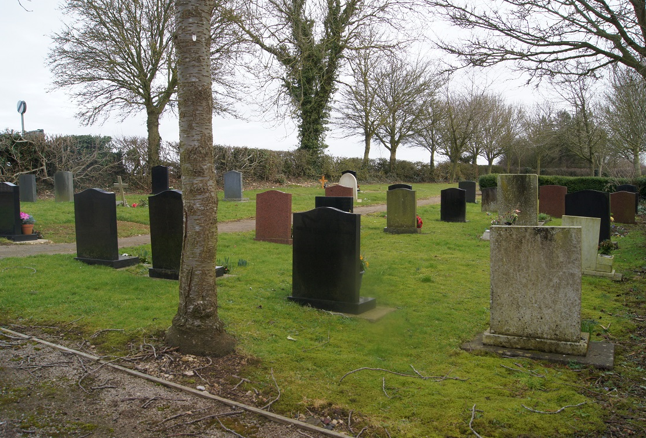  Smeeton Road Cemetery

